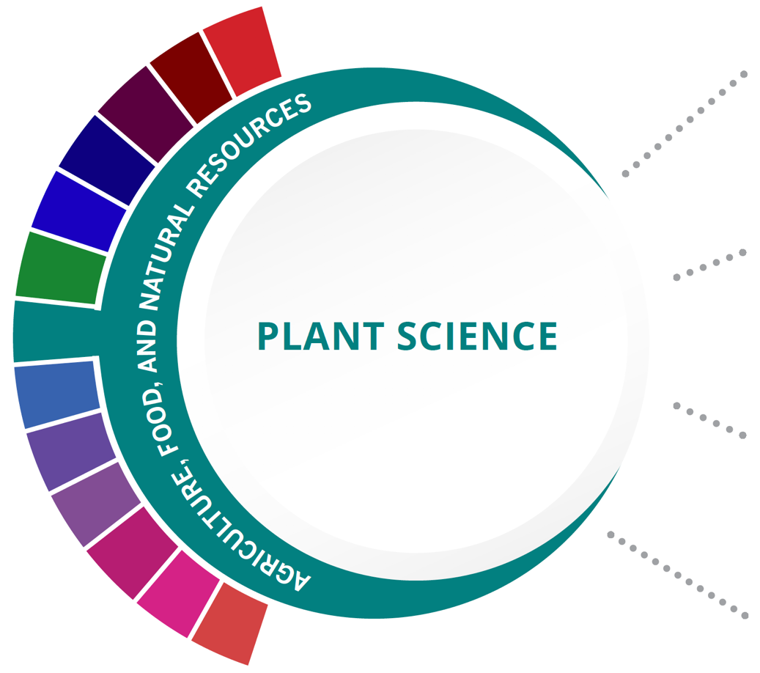
Statewide Program of Study: Plant Science; Agriculture, Food, and Natural Resources Career Cluster
Level 1 | Principles of Agriculture, Food, and Natural Resources
Level 2 | Greenhouse Operation and Production/Lab
Level 3 | Floral Design/Lab  Horticultural Science/Lab
Level 4 | Advanced Floral Design

HIGH SCHOOL/ INDUSTRY CERTIFICATION | CERTIFICATE/ LICENSE* | ASSOCIATE’S DEGREE | BACHELOR’S DEGREE | MASTER’S/ DOCTORAL PROFESSIONAL DEGREE
Landscape Irrigation Technician License | Pesticide Applicator | Applied Horticulture/  Horticulture Operations, General | Applied Horticulture/  Horticulture Operations, General | Applied Horticulture/  Horticulture Operations, General
Commercial/ Noncommercial Pesticide Applicator | Certified Floral Designer | Ornamental Horticulture | Agronomy and Crop Science | Agronomy and Crop Science
Texas State Floral Association Level One Floral Certification | Accredited Member of AIFD | Agricultural Business and Management, General | Agricultural Business and Management, General | Agricultural Business and Management, General
Texas State Floral Association Level Two Floral Certification | Landscape Industry Certified Technician | Turf and Turfgrass Management | Turf and Turfgrass Management | Farm/Farm and Ranch Management
Additional industry-based certification information is available on the TEA CTE website. For more information on postsecondary options for this program of study, visit TXCTE.org.
Occupations | Median Wage | Annual Openings | % Growth
Soil and Plant Scientists | $54,662 | 116 | 21%
Tree Trimmers and Pruners | $32,240 | 589 | 14%
Pesticide Handlers, Sprayers, and Applicators | $36,733 | 196 | 22%
Landscaping Supervisors | $44,408 | 807 | 19%
Biological Technicians | $42,931 | 452 | 17%

WORK BASED LEARNING AND EXPANDED
LEARNING OPPORTUNITIES
Exploration Activities: | Work Based Learning  Activities:
Texas FFA | Work part-time at a florist;  start or work for a local landscaping business  FFA Supervised Agriculture Experience (SAE)

The Plant Science program of study focuses on the science, research, and business of plants and other living organisms. It teaches students how to apply biology and life science to real-world life processes of plants and vegetation, either in laboratories or in the field.
The Agriculture, Food, and Natural Resources (AFNR) Career Cluster focuses on the essential elements of life—food, water, land, and air. This career cluster includes a diverse spectrum of occupations, ranging from farmer, rancher, and veterinarian to geologist, land conservationist, and florist. It also includes non-traditional agricultural occupations like wind energy, solar energy, and oil and gas production.

Successful completion of the Plant Science program of study will fulfill requirements of a Business and Industry endorsement or STEM endorsement if the math and science requirements are met. Revised - July 2020

COURSE INFORMATION

COURSE  NAME | SERVICE ID | PREREQUISITES (PREQ)  COREQUISITES (CREQ) | Grade
Principles of Agriculture, Food, and Natural Resources | 13000200 (1 credit) | None | 9-12
Floral Design/Lab | 13001800 (1 credit)  13001810 (2 credits) | None | 9-12
Horticultural Science/Lab | 13002000 (1 credit)  13002010 (2 credits) | None | 10-12
Advanced Floral Design | N1300270 (1 credit) | PREQ: Floral Design | 11-12
Greenhouse Operation and Production/Lab | 13002050 (1 credit)  13002060 (2 credits) | None | 10-12

FOR ADDITIONAL INFORMATION ON THE AGRICULTURE, FOOD, AND NATURAL RESOURCE CAREER CLUSTER, PLEASE CONTACT:
Les Hudson | Les.Hudson@tea.texas.gov
https://tea.texas.gov/cte

(District) offers career and technical education programs in (types of programs offered). Admission to these programs is based on (admission standards). It is the policy of (District) not to discriminate on the basis of race, color, national origin, sex or handicap in its vocational programs, services or activities as required by Title VI of the Civil Rights Act of 1964, as amended; Title IX of the Education Amendments of 1972; and Section 504 of the Rehabilitation Act of 1973, as amended. It is the policy of (District) not to discriminate on the basis of race, color, national origin, sex, handicap, or age in its employment practices as required by Title VI of the Civil Rights Act of 1964, as amended; Title IX of the Education Amendments of 1972; the Age Discrimination Act of 1975, as amended; and Section 504 of the Rehabilitation Act of 1973, as amended. (District) will take steps to assure that lack of English language skills will not be a barrier to admission and participation in all educational and vocational programs. For information about your rights or grievance procedures, contact the Title IX Coordinator at (physical address of Coordinator) (email address of Title IX Coordinator), (phone number of Title IX Coordinator), and the Section 504 Coordinator at (physical address of Coordinator), (email address of Section 504 Coordinator), (phone number of Section 504 Coordinator)

